**Name : Aarya Tiwari**

**Batch : B2:**

**Roll No. : 16010421119**

**Course: WP - II**

**Experiment No. : 8**

**Code:**

**Index.php**

<!DOCTYPE html>

<html lang="en">

<head>

    <meta charset="UTF-8">

    <meta name="viewport" content="width=device-width, initial-scale=1.0">

    <title>Experiment 8</title>

</head>

<body>

    <form>

        <input type="text" name="empId" id="empId" placeholder="Enter Employee ID">

        <input type="submit" value="Submit">

    </form>

    <?php

    if (isset($_GET['empId'])) {

        $empId = $_GET['empId'];

        $url = "http://localhost/exp8/rest.php/?id=" . $empId;

        $client = curl_init();

        curl_setopt_array($client, [

            CURLOPT_RETURNTRANSFER => 1,

            CURLOPT_URL => $url

        ]);

        $result = curl_exec($client);

        curl_close($client);

        echo "Response from the server";

        print_r($result);

    }

    ?>

</body>

</html>

**Rest.php**

<?php

$data = array(

    array("id" => 1, "name" => "Dhruv Sharma", "age" => 22),

    array("id" => 2, "name" => "Pratham Goenka", "age" => 23),

    array("id" => 3, "name" => "Aarya Tiwari", "age" => 24),

    array("id" => 4, "name" => "Dhairya Satra", "age" => 25),

    array("id" => 5, "name" => "Priyanshi Varshney", "age" => 26)

);

$id = $_GET['id'];

echo json_encode($data[$id - 1], JSON_PRETTY_PRINT);

?>

**Output:**



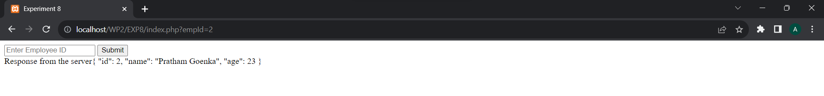

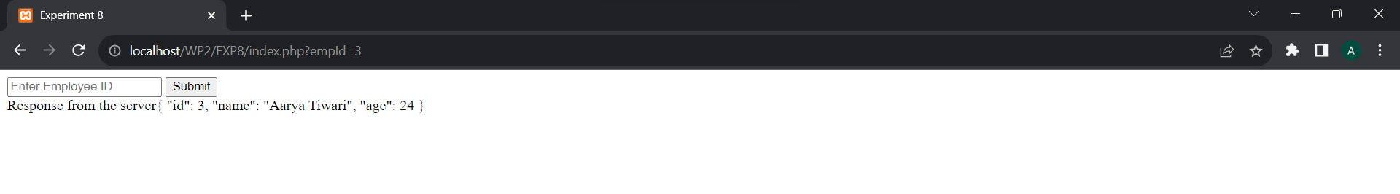

**Post Lab Questions:**

**1.What is the purpose of REST API**

Ans. The purpose of a REST (Representational State Transfer) API, or simply a RESTful API, is to provide a standardized and simple way for different software systems to communicate and exchange data over the internet. REST APIs are commonly used to enable the interaction between various web services, applications, and devices.

**2. What are the other alternatives to REST API**

Ans.

Alternatives are

* GraphQL
* gRPC
* websockets
* Event driven architecture
* FALCOR

**Outcomes:**

CO 4 Demonstrate the use advanced features such as REST API, email handling, localization and internationalization in PHP

**Conclusion:**

Implemented and called REST API made in this assignment